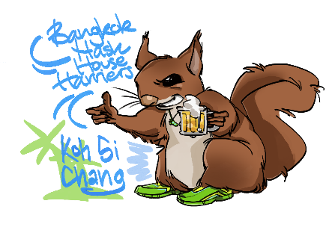
BH3 Koh Sichang Run
Open Outstation 18-20 Apr 2025
Hare Krinkle Kut, Co-hare Tinker

A weekend of Hashing where we’ll have fun, fun and fun!
A 1.5hour drive from Bangkok and then a 45min ferry ride
A trip down memory lane for the old farts and for others, a memorable discovery of the island.

Where? | When? | What?
Hash HQ – Sichang Palace Hotel. 400m from ferry | Fri 18th Ap | Check in/ Meet and greet
Rabiang Talay Restaurant almost over road from Hash HQ. Big sign | Fri 18th Apr 6pm | Prelube pissup and dinner
Hash HQ | Sat 19th Apr 3pm | BH3 Run 2455  Sawng taews to run starts. Your choice of long and medium
 |  | Circle at the swimming pool
Rabiang Talay Restaurant | Sat 19th Apr | OnOnOn
Hash HQ | Sun 20th Apr 10am | Recovery run by BSH3
 |  | Circle at the swimming pool
 | Later | On home! Last ferry 6pm

What will BH3 provide?
Beer, softies and water. Shirts. Sawng taew fares and post run nibbles, music.
And the runners and guests?
Accommodation costs, meals and transport there and back

BH3 will accept no responsibility for any injuries, accidents, emergencies, mishaps or other catastrophes. All participants participate at their own risk. The person signing this form accepts responsibility for themselves and all his/her guests.

To sign up –
Simply fill in the form below and email a copy of the form and bank transfer to -
Chris (Krinkle Kut) Smith chrissmithpng@gmail.com
and send (showing your hash handle) fees to -
Christopher Michael Smith UOB Bank, Account No 817 165 331 2
Alcoholics Bht 1,250
Others Bht 750

Participant/guest | Hash kennel | Hash handle | T shirt size | Amount
 |  |  | Bht | ___________

T Shirt size (No)
XS S M L XL XXL XXXL

Signature

